**1. Complete the missing numbers in the table below:**

|  |  |  |  |  |  |  |  |  |  |
| --- | --- | --- | --- | --- | --- | --- | --- | --- | --- |
| 1 |  |  |  |  | 6 |  |  | 9 |  |
|  | 12 |  |  | 15 |  |  |  |  |  |
|  |  |  | 24 |  |  |  |  |  |  |
| 31 |  |  |  |  |  | 37 |  |  | 40 |
|  |  |  |  |  | 46 |  |  |  |  |
|  |  | 53 |  |  |  |  |  |  |  |
|  |  |  |  |  |  |  |  |  | 70 |
|  |  |  |  | 75 |  |  |  |  |  |
|  | 82 |  |  |  |  |  | 88 |  |  |
|  |  |  |  |  |  |  |  |  |  |

**2. Complete the chart using skip counting:**

|  |  |  |  |  |  |  |  |  |  |
| --- | --- | --- | --- | --- | --- | --- | --- | --- | --- |
| 2 | 4 | 6 |  |  |  |  | 16 |  |  |
| 5 | 10 |  |  |  | 30 |  |  |  |  |
| 10 | 20 |  |  |  |  | 70 |  |  |  |

**3. Fill in the missing numbers:**

**_______, 6, _______ 10, _______, _______**

**_______, ________, 8 _______, 11, ________**

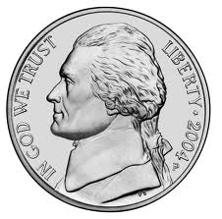**C:\Documents and Settings\hilljn\Local Settings\Temp\Temporary Internet Files\Content.IE5\65LBBXK1\MC900019342[1].wmf4. List the value of each coin below:**

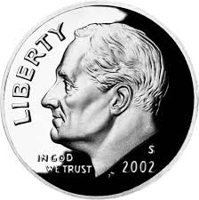

**__________ _________ _________**  **_________**

**5. How many objects are in each set?**

|  |  |
| --- | --- |
| **Objects** | **How many?** |
|  |  |
|  |  |
|  |  |

**6. Circle the set that has less**

**C:\Documents and Settings\hilljn\Local Settings\Temp\Temporary Internet Files\Content.IE5\C2EXLL1I\MC900417482[1].wmfC:\Documents and Settings\hilljn\Local Settings\Temp\Temporary Internet Files\Content.IE5\C2EXLL1I\MC900417482[1].wmfC:\Documents and Settings\hilljn\Local Settings\Temp\Temporary Internet Files\Content.IE5\C2EXLL1I\MC900417482[1].wmfC:\Documents and Settings\hilljn\Local Settings\Temp\Temporary Internet Files\Content.IE5\C2EXLL1I\MC900417482[1].wmfC:\Documents and Settings\hilljn\Local Settings\Temp\Temporary Internet Files\Content.IE5\C2EXLL1I\MC900417482[1].wmfC:\Documents and Settings\hilljn\Local Settings\Temp\Temporary Internet Files\Content.IE5\C2EXLL1I\MC900417482[1].wmf**

**C:\Documents and Settings\hilljn\Local Settings\Temp\Temporary Internet Files\Content.IE5\65LBBXK1\MC900438167[1].wmf**

**C:\Documents and Settings\hilljn\Local Settings\Temp\Temporary Internet Files\Content.IE5\65LBBXK1\MC900438167[1].wmfC:\Documents and Settings\hilljn\Local Settings\Temp\Temporary Internet Files\Content.IE5\65LBBXK1\MC900438167[1].wmfC:\Documents and Settings\hilljn\Local Settings\Temp\Temporary Internet Files\Content.IE5\65LBBXK1\MC900438167[1].wmf**

**C:\Documents and Settings\hilljn\Local Settings\Temp\Temporary Internet Files\Content.IE5\2MZITPNO\MC900151177[1].wmfC:\Documents and Settings\hilljn\Local Settings\Temp\Temporary Internet Files\Content.IE5\2MZITPNO\MC900151177[1].wmfC:\Documents and Settings\hilljn\Local Settings\Temp\Temporary Internet Files\Content.IE5\2MZITPNO\MC900151177[1].wmfC:\Documents and Settings\hilljn\Local Settings\Temp\Temporary Internet Files\Content.IE5\65LBBXK1\MC900346903[1].wmfC:\Documents and Settings\hilljn\Local Settings\Temp\Temporary Internet Files\Content.IE5\65LBBXK1\MC900346903[1].wmfC:\Documents and Settings\hilljn\Local Settings\Temp\Temporary Internet Files\Content.IE5\65LBBXK1\MC900346903[1].wmfC:\Documents and Settings\hilljn\Local Settings\Temp\Temporary Internet Files\Content.IE5\65LBBXK1\MC900346903[1].wmfC:\Documents and Settings\hilljn\Local Settings\Temp\Temporary Internet Files\Content.IE5\65LBBXK1\MC900346903[1].wmf7. Circle the set that has more**

**C:\Documents and Settings\hilljn\Local Settings\Temp\Temporary Internet Files\Content.IE5\65LBBXK1\MC900445096[1].wmfC:\Documents and Settings\hilljn\Local Settings\Temp\Temporary Internet Files\Content.IE5\65LBBXK1\MC900445096[1].wmfC:\Documents and Settings\hilljn\Local Settings\Temp\Temporary Internet Files\Content.IE5\65LBBXK1\MC900445096[1].wmfC:\Documents and Settings\hilljn\Local Settings\Temp\Temporary Internet Files\Content.IE5\65LBBXK1\MC900445096[1].wmfC:\Documents and Settings\hilljn\Local Settings\Temp\Temporary Internet Files\Content.IE5\65LBBXK1\MC900445096[1].wmfC:\Documents and Settings\hilljn\Local Settings\Temp\Temporary Internet Files\Content.IE5\65LBBXK1\MC900445096[1].wmfC:\Documents and Settings\hilljn\Local Settings\Temp\Temporary Internet Files\Content.IE5\65LBBXK1\MC900445096[1].wmf8. Color the first 4 Pictures:**

**C:\Documents and Settings\hilljn\Local Settings\Temp\Temporary Internet Files\Content.IE5\C2EXLL1I\MC900297917[1].wmfC:\Documents and Settings\hilljn\Local Settings\Temp\Temporary Internet Files\Content.IE5\C2EXLL1I\MC900297917[1].wmfC:\Documents and Settings\hilljn\Local Settings\Temp\Temporary Internet Files\Content.IE5\C2EXLL1I\MC900297917[1].wmfC:\Documents and Settings\hilljn\Local Settings\Temp\Temporary Internet Files\Content.IE5\C2EXLL1I\MC900297917[1].wmfC:\Documents and Settings\hilljn\Local Settings\Temp\Temporary Internet Files\Content.IE5\C2EXLL1I\MC900297917[1].wmfC:\Documents and Settings\hilljn\Local Settings\Temp\Temporary Internet Files\Content.IE5\C2EXLL1I\MC900297917[1].wmfC:\Documents and Settings\hilljn\Local Settings\Temp\Temporary Internet Files\Content.IE5\C2EXLL1I\MC900297917[1].wmfC:\Documents and Settings\hilljn\Local Settings\Temp\Temporary Internet Files\Content.IE5\C2EXLL1I\MC900297917[1].wmfC:\Documents and Settings\hilljn\Local Settings\Temp\Temporary Internet Files\Content.IE5\C2EXLL1I\MC900297917[1].wmfC:\Documents and Settings\hilljn\Local Settings\Temp\Temporary Internet Files\Content.IE5\C2EXLL1I\MC900297917[1].wmf9. Color the Last 6 Pictures**

**10. Color the Middle 3 Pictures:**

**C:\Documents and Settings\hilljn\Local Settings\Temp\Temporary Internet Files\Content.IE5\C2EXLL1I\MC900090985[1].wmfC:\Documents and Settings\hilljn\Local Settings\Temp\Temporary Internet Files\Content.IE5\C2EXLL1I\MC900090985[1].wmfC:\Documents and Settings\hilljn\Local Settings\Temp\Temporary Internet Files\Content.IE5\C2EXLL1I\MC900090985[1].wmfC:\Documents and Settings\hilljn\Local Settings\Temp\Temporary Internet Files\Content.IE5\C2EXLL1I\MC900090985[1].wmfC:\Documents and Settings\hilljn\Local Settings\Temp\Temporary Internet Files\Content.IE5\C2EXLL1I\MC900090985[1].wmf**

**11. Find the sum of the objects:**

**C:\Documents and Settings\hilljn\Local Settings\Temp\Temporary Internet Files\Content.IE5\DP0DLC4F\MC900440227[1].wmf**

**C:\Documents and Settings\hilljn\Local Settings\Temp\Temporary Internet Files\Content.IE5\DP0DLC4F\MC900440227[1].wmfC:\Documents and Settings\hilljn\Local Settings\Temp\Temporary Internet Files\Content.IE5\DP0DLC4F\MC900440227[1].wmfC:\Documents and Settings\hilljn\Local Settings\Temp\Temporary Internet Files\Content.IE5\DP0DLC4F\MC900440227[1].wmfC:\Documents and Settings\hilljn\Local Settings\Temp\Temporary Internet Files\Content.IE5\DP0DLC4F\MC900440227[1].wmfC:\Documents and Settings\hilljn\Local Settings\Temp\Temporary Internet Files\Content.IE5\DP0DLC4F\MC900440227[1].wmfC:\Documents and Settings\hilljn\Local Settings\Temp\Temporary Internet Files\Content.IE5\DP0DLC4F\MC900440227[1].wmfC:\Documents and Settings\hilljn\Local Settings\Temp\Temporary Internet Files\Content.IE5\DP0DLC4F\MC900440227[1].wmfC:\Documents and Settings\hilljn\Local Settings\Temp\Temporary Internet Files\Content.IE5\DP0DLC4F\MC900440227[1].wmf + =**

**C:\Documents and Settings\hilljn\Local Settings\Temp\Temporary Internet Files\Content.IE5\65LBBXK1\MC900438249[1].wmfC:\Documents and Settings\hilljn\Local Settings\Temp\Temporary Internet Files\Content.IE5\65LBBXK1\MC900438249[1].wmfC:\Documents and Settings\hilljn\Local Settings\Temp\Temporary Internet Files\Content.IE5\65LBBXK1\MC900438249[1].wmfC:\Documents and Settings\hilljn\Local Settings\Temp\Temporary Internet Files\Content.IE5\65LBBXK1\MC900438249[1].wmfC:\Documents and Settings\hilljn\Local Settings\Temp\Temporary Internet Files\Content.IE5\65LBBXK1\MC900438249[1].wmfC:\Documents and Settings\hilljn\Local Settings\Temp\Temporary Internet Files\Content.IE5\65LBBXK1\MC900438249[1].wmfC:\Documents and Settings\hilljn\Local Settings\Temp\Temporary Internet Files\Content.IE5\65LBBXK1\MC900438249[1].wmfC:\Documents and Settings\hilljn\Local Settings\Temp\Temporary Internet Files\Content.IE5\65LBBXK1\MC900438249[1].wmf**

**C:\Documents and Settings\hilljn\Local Settings\Temp\Temporary Internet Files\Content.IE5\65LBBXK1\MC900438249[1].wmfC:\Documents and Settings\hilljn\Local Settings\Temp\Temporary Internet Files\Content.IE5\65LBBXK1\MC900438249[1].wmf** **+ =**

 **+ =**

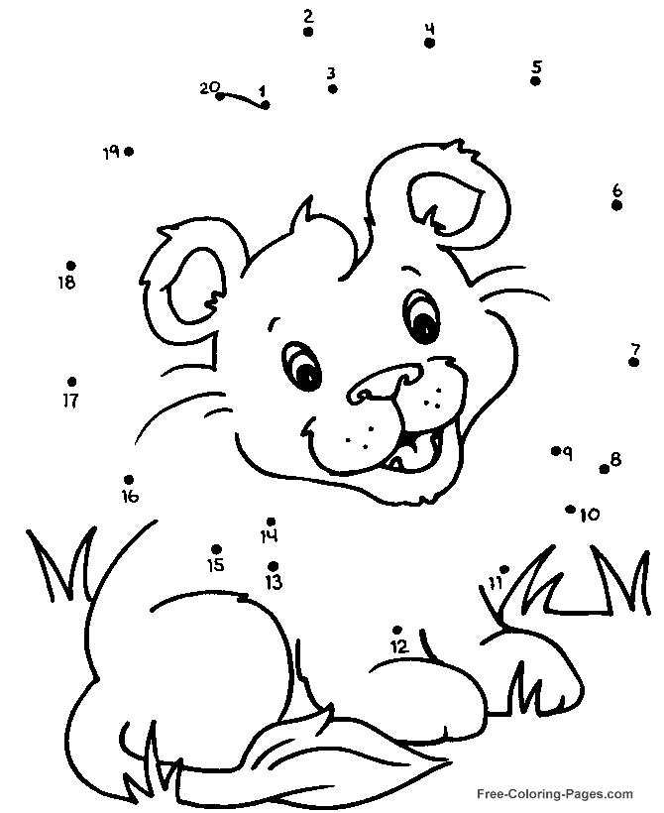**12. Connect the dots to complete the picture:**

**13. Write the numbers from smallest to largest:**

**15, 4, 20, 12**

A. 4, 20, 15, 12

B. 12, 15, 20, 4

C. 4, 12, 15, 20

D. 20, 15, 12, 4

**14. Write the numbers from smallest to largest:**

**16, 24, 6, 3**

A. 6, 24, 3, 16

B. 3, 6, 16, 24

C. 24, 16, 6, 3

D. 3, 16, 6, 24

**15. Circle the Triangle:**

**16. Circle the Rectangle:**

**17. Which object is different from the others?**

**How is it different?**

**18. Place an X over the geometric shape that does not belong**

**19. Draw the hands on the clock:**

**What does 9:00 o’clock look like?**

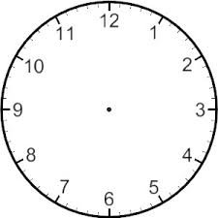

**What does 3:00 o’clock look like?**



**20. If today is Monday, what is tomorrow? Circle one.**

**Sunday Tuesday Wednesday**

**21. If today is Saturday, what was yesterday? Circle one.**

**Friday Sunday Monday**

**22. If today is Wednesday, what is tomorrow? Circle one.**

**Monday Tuesday Thursday**

**23. If today is Tuesday, what was yesterday? Circle one.**

**Sunday Monday Wednesday**

**24. What part of the day do you wake up? Circle one.**

**Morning Afternoon Evening**

**25. What part of the day do you go to bed? Circle one.**

**Morning Afternoon Evening**

**26. What tool do you use to tell time? Circle one.**

**Ruler Clock Scale**

**27. What does a clock show you? Circle the answer.**

**A. What time it is?**

**B. What day of the week it is?**

**C. What month it is?**

**28. Circle the person that is taller.**

**Mom Baby**

**29. Circle the picture that is smaller.**

**30. 1 nickel is equal to. Circle the answer.**

**1 cent 5 cent 10 cent**

**31. 1 dime is equal to. Circle the answer.**

**1 cent 5 cent 10 cent**

**32. Complete the chart:**

|  |  |  |  |  |  |  |  |  |  |
| --- | --- | --- | --- | --- | --- | --- | --- | --- | --- |
| 1 |  |  |  | 5 |  | 7 |  |  |  |
|  | 12 |  | 14 |  |  |  | 18 |  |  |
| 21 |  | 23 |  |  | 26 |  |  | 29 |  |
|  | 32 |  | 34 |  |  |  | 38 |  | 40 |
| 41 |  | 43 |  | 45 |  |  |  | 49 |  |
|  | 52 | 53 |  |  | 56 |  |  |  | 60 |
| 61 |  |  | 64 |  |  | 67 |  | 69 |  |
|  |  |  | 74 |  | 76 |  | 78 |  |  |
|  | 82 |  |  | 85 |  | 87 | 88 |  | 90 |
|  |  | 93 |  |  | 96 |  |  | 99 |  |

**Use the chart above to complete the following:**

**33. Count by 5’s and color the numbers red.**

**34. Count by 2’s and color the numbers blue.**

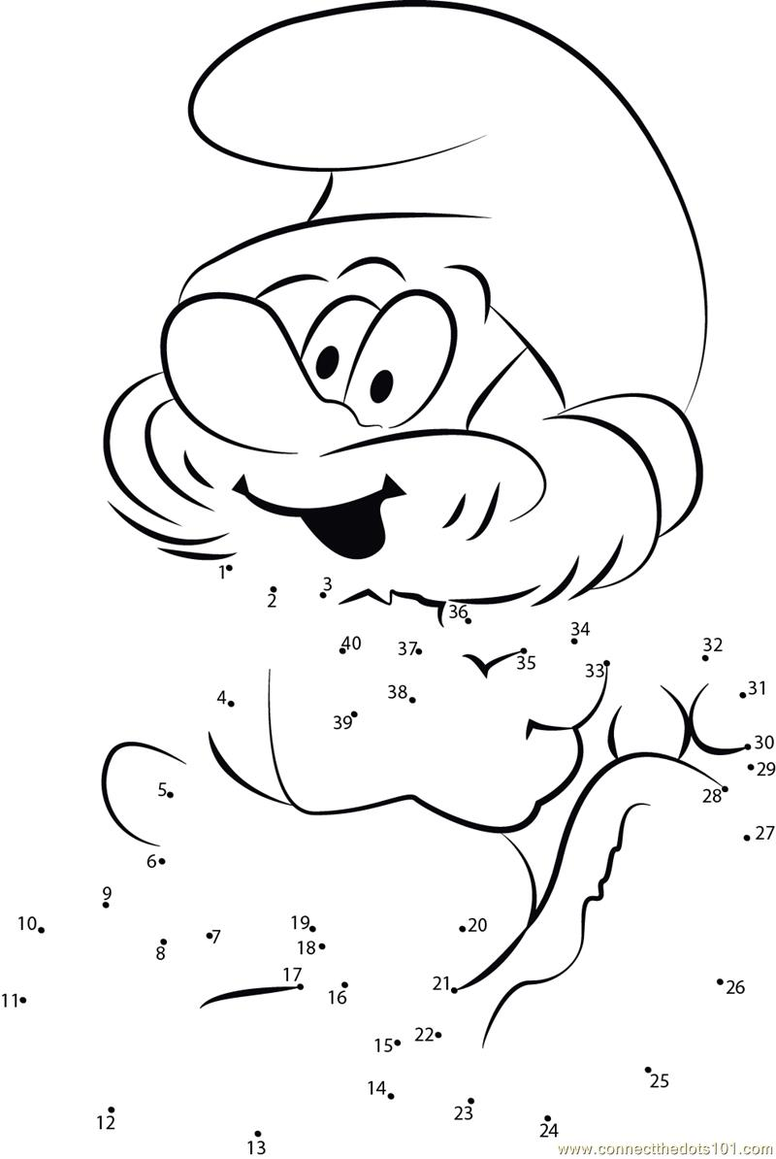**35. Connect the dots to complete the picture:**

**36. Draw a line to match the coin with the right name.**



**Front of Dime**

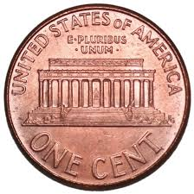

**Back of Penny**



**Back of Nickel**

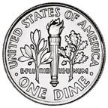**Front of Penny**

**C:\Documents and Settings\hilljn\Local Settings\Temp\Temporary Internet Files\Content.IE5\65LBBXK1\MC900019342[1].wmf**

**Front of Nickel**

**37. Circle the group that has the most.**

**C:\Documents and Settings\hilljn\Local Settings\Temp\Temporary Internet Files\Content.IE5\DP0DLC4F\MC900438169[1].wmfC:\Documents and Settings\hilljn\Local Settings\Temp\Temporary Internet Files\Content.IE5\DP0DLC4F\MC900438169[1].wmfC:\Documents and Settings\hilljn\Local Settings\Temp\Temporary Internet Files\Content.IE5\DP0DLC4F\MC900438169[1].wmfC:\Documents and Settings\hilljn\Local Settings\Temp\Temporary Internet Files\Content.IE5\DP0DLC4F\MC900438169[1].wmfC:\Documents and Settings\hilljn\Local Settings\Temp\Temporary Internet Files\Content.IE5\DP0DLC4F\MC900438169[1].wmfC:\Documents and Settings\hilljn\Local Settings\Temp\Temporary Internet Files\Content.IE5\DP0DLC4F\MC900438169[1].wmfC:\Documents and Settings\hilljn\Local Settings\Temp\Temporary Internet Files\Content.IE5\DP0DLC4F\MC900438169[1].wmfC:\Documents and Settings\hilljn\Local Settings\Temp\Temporary Internet Files\Content.IE5\DP0DLC4F\MC900438169[1].wmfC:\Documents and Settings\hilljn\Local Settings\Temp\Temporary Internet Files\Content.IE5\DP0DLC4F\MC900438169[1].wmfC:\Documents and Settings\hilljn\Local Settings\Temp\Temporary Internet Files\Content.IE5\DP0DLC4F\MC900438169[1].wmfC:\Documents and Settings\hilljn\Local Settings\Temp\Temporary Internet Files\Content.IE5\DP0DLC4F\MC900438169[1].wmfC:\Documents and Settings\hilljn\Local Settings\Temp\Temporary Internet Files\Content.IE5\DP0DLC4F\MC900438169[1].wmfC:\Documents and Settings\hilljn\Local Settings\Temp\Temporary Internet Files\Content.IE5\DP0DLC4F\MC900438169[1].wmfC:\Documents and Settings\hilljn\Local Settings\Temp\Temporary Internet Files\Content.IE5\DP0DLC4F\MC900438169[1].wmfC:\Documents and Settings\hilljn\Local Settings\Temp\Temporary Internet Files\Content.IE5\DP0DLC4F\MC900438169[1].wmfC:\Documents and Settings\hilljn\Local Settings\Temp\Temporary Internet Files\Content.IE5\DP0DLC4F\MC900438169[1].wmfC:\Documents and Settings\hilljn\Local Settings\Temp\Temporary Internet Files\Content.IE5\DP0DLC4F\MC900438169[1].wmf**

**38. Which number is ONE MORE than 4? Circle the answer.**

**3 5 6 7**

**39. Which number is ONE LESS than 7? Circle the answer.**

**4 5 6 8**

**40. Which object will be heavier? Circle the answer.**

**A. A Pencil**

**B. A Basketball**

**41. Which object would be lighter? Circle the answer.**

**A. A roll of tissue**

**B. A can good item**

**Complete the pattern:**

**42.**

**______ _______**

**43.**

**44. Draw a line from the number to the word.**

**1 four**

**2 seven**

**3 two**

**4 ten**

**5 six**

**6 one**

**7 three**

**8 nine**

**9 five**

**10 eight**

**45. Fill in the blanks below:**

**Before After Between**

**______ 16 22 _______ 4 _____ 6**

**______ 20 10 _______ 13 _____ 15**

**______ 29 18 _______ 17 _____ 19**

**46. Circle the larger number:**

**6 8 15 12 65 62**

**27 32 45 54 17 21**

**46 33 20 19 51 60**

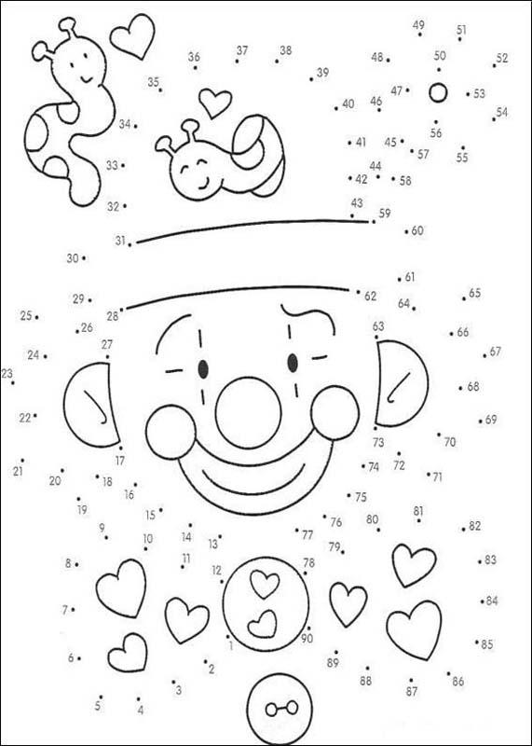**47. Connect the dots to complete the picture.**

**48. How much money is this? Circle the answer.**

**C:\Documents and Settings\hilljn\Local Settings\Temp\Temporary Internet Files\Content.IE5\65LBBXK1\MC900019342[1].wmfC:\Documents and Settings\hilljn\Local Settings\Temp\Temporary Internet Files\Content.IE5\65LBBXK1\MC900019342[1].wmfC:\Documents and Settings\hilljn\Local Settings\Temp\Temporary Internet Files\Content.IE5\65LBBXK1\MC900019342[1].wmfC:\Documents and Settings\hilljn\Local Settings\Temp\Temporary Internet Files\Content.IE5\65LBBXK1\MC900019342[1].wmf**

1. **4 cents**
2. **20 cents**
3. **40 cents**

**C:\Documents and Settings\hilljn\Local Settings\Temp\Temporary Internet Files\Content.IE5\65LBBXK1\MC900019342[1].wmfC:\Documents and Settings\hilljn\Local Settings\Temp\Temporary Internet Files\Content.IE5\65LBBXK1\MC900019342[1].wmfC:\Documents and Settings\hilljn\Local Settings\Temp\Temporary Internet Files\Content.IE5\65LBBXK1\MC900019342[1].wmf49. How much money is this? Circle your answer.**

1. **3 cents**
2. **15 cents**
3. **30 cents**

**50. Decide how many are left.**

**Tiffany has 9 cupcakes, and eat two. How many does she have left?**



How many are left?

**Tiffany has 7 cupcakes, and loses 3. How many does she have left?**



How many are left?